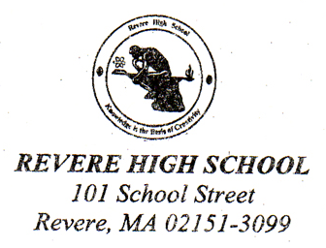

RSVP for
2010 Revere High School Science Fair
on Thursday February 25th 2010, at 8:00 AM
Snow date: Friday February 26th 2010
in the Revere High School Library

Name: __________________________________________________

Organization: __________________________________________________

Please check:

- I will be able to participate in your annual Science Fair on Thursday February 25th 2010, at 8:00 AM.

- I am sorry I will be unable to attend this year’s fair. Please keep me on your list of potential judges and hopefully I can judge in the future.

- I am unable to judge Science Fairs. Please remove me from your contact list.

- I would be interested in becoming a mentor for future science fair participants.

The following people may also wish to judge the Revere High School Science Fair. Please forward them an invitation.

Name / Address ____________________________________________________________________

Name / Address ____________________________________________________________________

- My organization / company would be interested in sponsoring a Student Prize. Please contact me (include phone or email) .

- A donation for the Revere High School Science Fair is enclosed.

Please send to the attention of:

Mr. David Eatough
Revere High School
101 School Street
Revere MA 02151

You may also respond by email to deatough@revere.mec.edu

Thank you for your continued support of science at Revere High School

