Expedition diary with photographs
Optical Communications underwater -- submarine use
E. K. Sichel
Talk at the Woods Hole Public Library, March 1 , 7:30 PM

Two underwater optical communication systems have been developed by research teams at WHOI for use with seafloor sensors in an ocean observatory and other projects. Enid Sichel will describe a WHOI expedition to deploy and test the instruments on the ocean floor. Pictured below during the expedition is Alvin Pilot, Mark Spear, Enid Sichel and Katherine Inderbitzen, a graduate student at Univ. Miami.

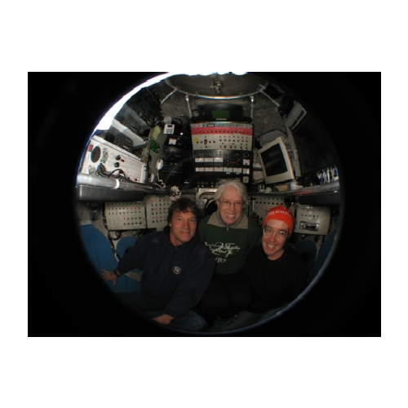
Enid Sichel, a physicist, has recently retired from the Massachusetts Maritime Academy. She continues to work with WHOI colleagues as a guest scientist.

