Falmouth Bandshell – Scranton Ave. Falmouth, MA
Fiddle Fest
2010
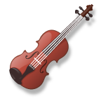
The Sonnay Fiddlers - Performing Traditional Irish, Scottish, and American music.
www.sonnayfiddlers.org

Tuesday July 6th and 20th

6:00pm – 7:30pm
FREE

Also Appearing - Award Winning Celtic Duo
Stanley and Grimm

Bring your picnic basket, chairs and blankets!!!

Thank you for your support…

