“Laughing Away The Blues”
A Night of Comedy and Dancing
With Boston’s Steve Sweeney and Friends

To Benefit the Cape and Islands Suicide Prevention Coalition
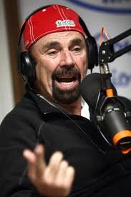
Saturday July 7th at 6:30PM Ballymeade Country Club
DJ Hors d’oeurvres Raffle Silent Auction Cash Bar
$30-$35 at the door
Tickets Available Now ! at: events.r20.constantcontact.com
an ages 18+ Show

Sponsored by; The Falmouth Road Race, Cape Cod Healthcare,
The Cape and Islands Suicide Prevention Coalition

