THE ASHE COLLECTION
Premium Style in a Borderless World
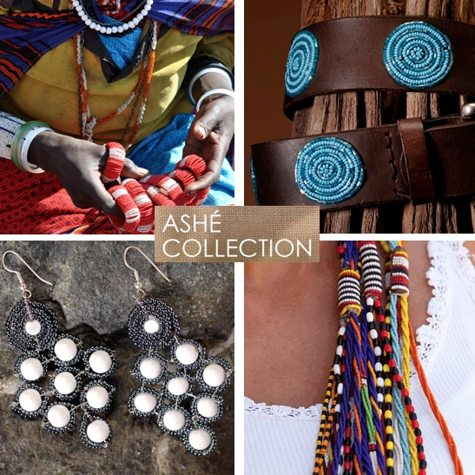
In early 2011 UNITE The World With Africa launched The Ashe Collection to help grow an international audience and demand for artists of East Africa as well as to raise money in support of UNITE’s work to advance women’s health, education and microfinance programs across Tanzania. Created in partnership with the award-winning brand development agency MILK in South Norwalk, Connecticut, the ASHE Collection (which means “thank you” in Kimaa, the language of the Maasai) is is now our portal of discovery, community and great style. We invite you to explore, shop and celebrate as we redefine where great fashion comes from.
Thursday, July 12 - 4-7pm at Greene's (9 Penzance Point)
For more info contact Josie Greene 617 513-2814

Paris – Milan – New York – Tanzania
ASHE!
