Wild Turkeys on Cape Cod
During the 1990's, 18 birds were released at the Massachusetts Military Reservation, and 20 others on the Outer Cape on private property in Wellfleet adjacent to the Cape Cod National Seashore.
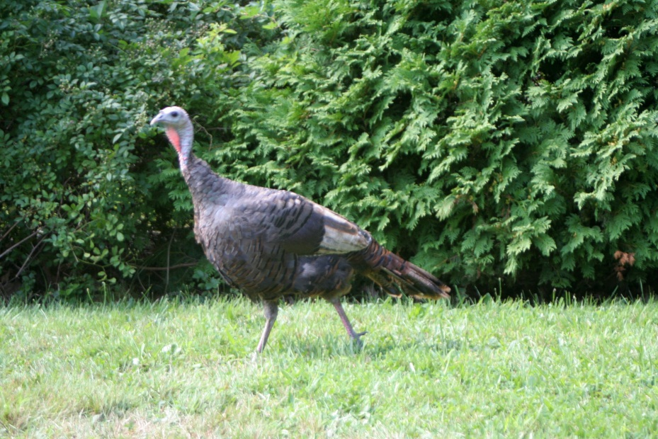
Brian Malone, a retired natural resources officer, will share his extensive knowledge and passion for wild turkeys and describe the efforts he participated in to restore this species in Massachusetts. How and when did turkeys become re-established on Cape Cod? What is the pattern of their roving lifestyle? How do they survive winter and predators?
Sunday, September 16th at 2:30 p.m.
Sandwich Grange Hall
91 Old County Road, East Sandwich
Suggested Donation $5

Presented by the Sandwich Conservation Trust


For more information, please contact:
John Cullity 508-888-7629 Joe Queenan 508-833-0861

