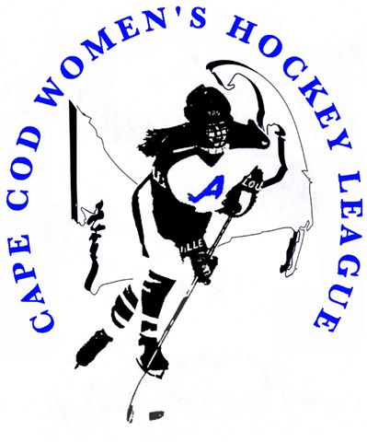

Cape Cod Women's Hockey League
2014 – 2015 Season

Looking for a great workout
in a very supportive environment?

The Cape Cod Women’s Hockey League is getting ready to kick off another season!
New members are always welcome!!

Players: Women with a desire to play ice hockey
(no experience needed)

Ages: 18 years old and up

Games: Saturday Nights at Falmouth Rink

League Website: www.ccwhl.com

Don’t Miss Out ~ stop by the rink and check it out!

