For Sale 2010 Honda Fit

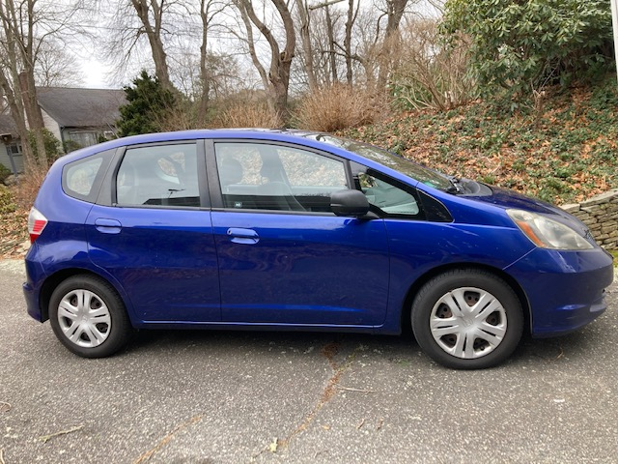

$4,000 or best offer
as is
146,000 miles
Standard shift 5 speed
Tow hitch
Good tires
rough spots : bumps scratches some rust
Woods Hole
email loganwoho@comcast.net



